**[Client name]**

Routes to making an

employee shareholder



Contents

Background and scope of work 3

Your Team 3

Executive summary 4

Enterprise Management Incentive scheme 6

Growth shares 10

Issues of ordinary shares 13

*This document is the property of Haines Watts North East. It is confidential and intended solely for use by personnel authorised by the organisation whose name appears on the cover page. Any review, transmission, dissemination or other use of or taking of any action in reliance upon this information by persons or entities other than the intended users is prohibited.*

# 

# Background and scope of work

Wilson Gray Consulting Ltd (WGC) is a mechanical and electrical building services practice.

We understand that you wish to make an employee a shareholder in the company. There are a number of different routes to achieving this. The purpose of this report is to set out the key features of three routes that might be suitable:

* Enterprise Management Incentive scheme
* Growth shares
* Issue of ordinary shares at market value

This report sets out the key points of each route as well as their advantages and disadvantages. The aim of the report is to assist you in the decision-making process.

# Your Team

Please don’t hesitate to contact us:

**Jonathan Scott**

[jscott@hwca.com](mailto:jscott@hwca.com)

[***07972056399***](tel:07972056399)

Louise Cottam

[lcottam@hwca.com](mailto:lcottam@hwca.com)

*0191 269 9960*

# Executive summary

Set out below is a table showing the key points of each of the three routes for an employee to become a shareholder:

|  |  |  |  |
| --- | --- | --- | --- |
|  | **EMI** | **Growth shares** | **Ordinary shares** |
| **Overview** | * Options are granted to the employee over ordinary share capital * Employee can exercise the options if they meet conditions (as chosen by the company) * Employee sells shares and receives the relevant proportion of the proceeds | * Employee subscribes to a new class of shares which essentially only gains value as profits are generated in the future * The value of the shares may only increase if certain hurdles are met (as chosen by the company) * Upon sale of shares the employee is only entitled to a share of the proceeds above the hurdle value | * Employee subscribes for ordinary shares i.e. the same type of shares as is in existence * The employee has the same rights as the other shareholders * Employee sells shares and receives the relevant proportion of the proceeds |
| **Tax implications for employee** | * No income tax or NICs arises upon grant of the options * No income tax or NICs arise upon exercise (assuming the market value (MV) at grant is paid) * Upon sale capital gains tax (CGT) is paid at 10% | * No income tax or NICs arise upon subscription of the shares as long as MV is paid * Usually the new shares would have a low or nominal MV. * Upon sale CGT would be due at 20% (unless the employee qualifies for Business Asset Disposal Relief then this would reduce to 10%) | * If the employee pays less than MV for the shares then income tax (and possibly NICs) may arise upon subscription * Upon sale CGT would be due at 20% (unless the employee qualifies for Business Asset Disposal Relief then this would reduce to 10%) |
| **Conditions?** | * There are conditions that both the employee and company must meet. * Also, the company can add conditions | * Only those chosen by the company | * No * Once the employee has shares they will hold the same rights as the other shareholders. |
| **Key advantages** | * Tax benefits * The company can choose when the employee has the right to exercise the options * The company can distinguish between good/bad leavers * The company can require the employee to sell their shares back if they leave * Can incentivise key staff due to the potential growth in the value of the shares | * The employee can only benefit from the future uplift in the value of the company * The company can choose hurdles that must be achieved before the shares earn value * The company can distinguish between good/bad leavers * The company can require the employee to sell their shares back if they leave * Can incentivise key staff due to the potential growth in the value of the shares * Could pay dividends to the employees if desired | * Simple |
| **Downsides?** | * The EMI income tax reliefs are reduced or extinguish if a disqualifying event occurs * There is a cost to set up the scheme * There are ongoing maintenance costs of an EMI scheme due to annual Employment Related Securities (ERS) returns | * No special tax benefits * There is still a reasonable implementation cost, largely due to the legal paperwork required * Would need to consider on an annual basis whether an ERS return was required | * No special tax benefits * The employee will benefit from the historic growth of the company should they sell their shares * The interests of the existing shareholders are immediately diluted. * The employee will have the same rights as the other shareholders (e.g. to dividends etc) * Would need to consider on an annual basis whether an ERS return was required |

# Enterprise Management Incentive scheme

## What is an EMI scheme?

The Enterprise Management Incentive (EMI) scheme is a flexible, tax advantageous employee share scheme available to most trading companies.

How does an EMI scheme work?

Under the scheme there are three stages to the employee share ownership:

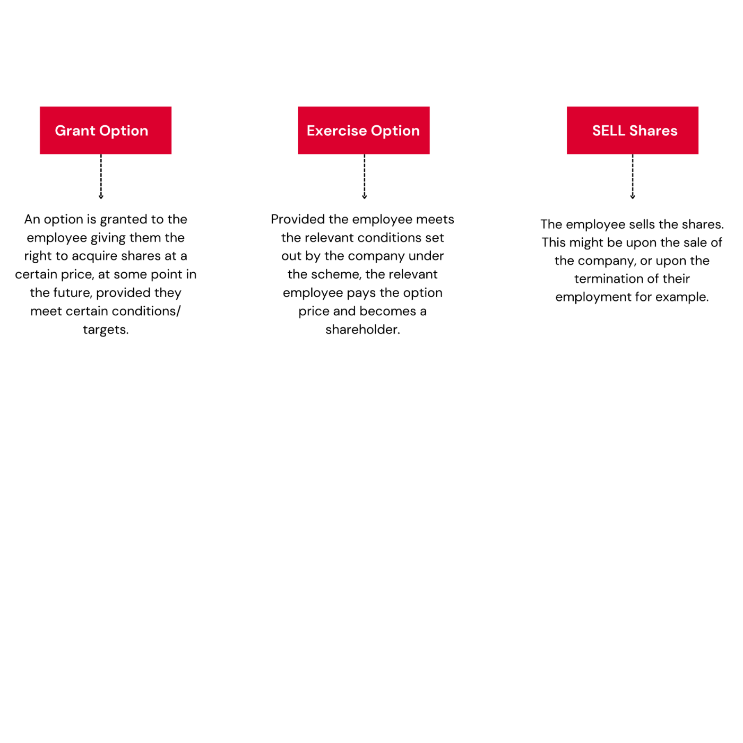

## Are there any conditions/rules set out in legislation that must be met?

Yes. As an HMRC approved scheme, there are number of requirements that must be met to have a qualifying scheme.

Key criteria – employees:

* Working time – the employee must either work a minimum of 25 hrs a week for the company or work at least 75% of their total working time for the company (for example if an employee works 16 hours a week for the company and 4 hours a week in a second job then they would still qualify because they work 80% of their time at the company)
* Material interest – the individual cannot have a material interest in the company, which is set at 30%. The interests of the individual’s associates (e.g. relatives or partner) are included within the 30%

Key criteria – company employer:

* Independence – the issuing company must not be a 51% subsidiary of a company or be controlled by another company.
* Subsidiaries – a company can only issue EMI options if all of its subsidiaries would also qualify under the scheme.
* Gross assets – must not exceed £30m
* Number of employees – must be less than 250 (for the company and any group members).
* UK permanent establishment – the company must have a permanent establishment in the UK.
* Qualifying trade – the company must exist for the purpose of carrying out a qualifying trade. Excluded activities include:
  + Dealing in land and/or property development
  + Banking, insurance, debt factoring
  + Leasing
  + Royalties and license fees

## What is the tax position?

*Employee:*

A key tax advantage to the employee is that there is no income tax or NIC to pay when the options are granted.

Upon exercise of the options the employee will have no income tax or NIC to pay if the exercise price is equal to or above the actual market value (AMV) of the options at the time they were awarded. This value can be agreed with HMRC prior to setting up the scheme.

If the exercise price is below the AMV at the time of their award, then income tax (and possibly NICs) will be chargeable.

When the employee sells the shares currently they will pay capital gains tax at the reduced rate of 10% as long as they have held either the option or the shares for at least two years. This is because EMI shares qualify for Business Asset Disposal Relief.

*Employer:*

The company will qualify for a deduction from its taxable profits based on the difference between the market value of the share options exercised and the option price in the financial year in which the options are exercised.

## What are the key advantages of an EMI?

* Tax savings – as explained above.
* Flexibility – whilst there are requirements which must be met according to the legislation, the company can decide the key features of their scheme. For example:
  + The employee’s right to exercise the share options can be made subject to explicit performance targets (e.g. turnover increases), objectives related to the individual’s role, time based (e.g. upon the 3rd anniversary of the grant) as long as it is within 10 years of grant, or only when the company is sold.
  + The company can set the exercise price and the option period, therefore giving them control over the value of the benefit to the employee
  + The company can choose who benefits under the scheme (subject to a material interest barrier of 30%)
  + The company can distinguish between “good leavers” and “bad leavers” e.g. if an employee leaves due to disability they may be allowed to exercise their options, but someone who just leaves for a new job can’t.
  + The company can require an employee to sell their shares back to the company if they leave
* Incentive – it can be an excellent incentive to retain key staff due to the potential growth in the value of the shares and the fact that most option agreements lapse if an employee leaves.
* Employee engagement – where staff have a tangible interest in the company they may be more motivated to generate profits and build up the value of the company.

## Are there any downsides to setting up an EMI scheme?

Like all things there are some downsides, these include:

* The EMI income tax reliefs are reduced or are not available if a disqualifying event occurs. At a high level this is where the company or the employee no longer meets the key criteria.
* There is a cost to set up the scheme (see details below on what is involved in setting up a scheme)
* There are small ongoing maintenance costs of an EMI scheme. This is because on an annual basis the company must file an Employment Related Securities Return with HMRC. This is something that we could assist with.
* The employees do not hold shares from day one of the scheme. This may be a disadvantage if you had wanted to make dividend payments to the employees.

## What is involved in setting up an EMI scheme?

There are a number of steps involved in setting up an EMI scheme.

* Establish that the company qualifies.
* Working with your advisors, devise and structure the scheme – for example a company must decide:
  + Which employees to include
  + Whether the options are granted at a discount, existing MV or at another figure (note it is only possible to grant options worth £250k per individual)
  + What will the minimum exercise period be? A typical period is 3 years.
  + Are there any conditions to be set e.g. around performance?
* Agree a share valuation – we would always strongly recommend that a share valuation is prepared and agreed with HMRC prior to granting any options. This fixes the value by reference to which tax (if any) is calculated in the future. This is something that we can assist with.
* Draw up an agreement or scheme rules – we would recommend using a lawyer to draw up the option agreement and any associated documents to ensure that you don’t fall foul of employment law or tax legislation.
* Present the scheme to staff – depending upon the company, the relevant staff members may have been involved at an earlier stage.
* Notify HMRC – the employer must register online with HMRC share scheme reporting service to report the grant of options. This report must be made within 92 days, therefore registration must be made within good time (this is something we can assist with).
* Monitoring the scheme and annual returns – it is necessary to ensure that the EMI scheme runs in accordance with the legislation and avoid disqualifying events. Furthermore, an annual return must be made to HMRC by 6 July following each tax year regarding the scheme.

# Growth shares

## What are grow shares?

Growth shares are also known as hurdle or flowering shares.

They are a special class of shares issued by a company to employees. They enable the employees to participate only in the increased value of the company if a hurdle is met. As a result, the original shareholders’ interests are only diluted if/when the hurdle is met.

## How do growth shares work?

On day one, the relevant employee subscribes for shares from a specific class of shares which has been designed especially for this purpose.

Generally, these new shares have little or no commercial value upon issue, this is because the value is not created, or does not “flower”, until the hurdle is met.

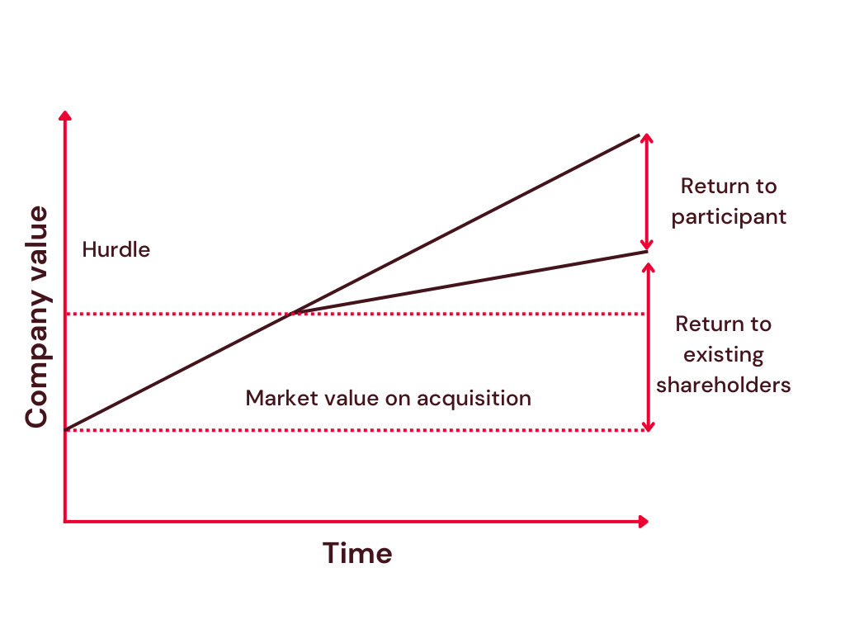

## Are there any conditions/rules set out in tax legislation that must be met?

As no special tax reliefs are available in relation to growth shares there are no specific conditions that must be met for tax purposes.

The company must however abide by company law and employment law and ensure that all relevant paper work has been prepared (as is also the case with the issue of any shares).

## What is the tax position?

*Employee:*

As long as the employee pays market value for the shares upon subscription, there would be no tax arising on the employee. Usually the value of the shares at subscription is low or nominal.

If however there is a shortfall between the amount paid by the employee and the market value at acquisition then the difference would be taxable as earnings (i.e. income tax and possibly NICs would be due).

When the employee sells the shares, they would be charged capital gains tax. The standard rate of capital gains tax is 20%.

It is possible that the individual may qualify for Business Asset Disposal Relief and be charged CGT at 10%. In summary, they may qualify if they have owned the shares for at least 2 years before sale and during that period their shareholding represents at least 5% of:

* The nominal value of the company’s ordinary share capital
* The voting rights in the company
* The company’s assets upon winding up

*Employer:*

There is no Corporation Tax deduction available in relation to the growth in the value of the shares.

## What are the key advantages of growth shares?

* Flexibility – the company can design the class of shares how they wish
  + The company can choose which employees are eligible to acquire shares
  + The company can set the price of the shares
  + The company can impose restrictions on transfer, or forfeiture if specified conditions or targets are not achieved or the employee ceases employment.
  + The company can distinguish between “good leavers” and “bad leavers”.
  + The company can require an employee to sell their shares back to the company if they leave
* Whilst there are no specific tax advantages to growth shares they are still tax efficient. In particular, due to their low value upon issue, any tax charge at that point will be low. Furthermore, the growth in the value of the shares will be taxed under CGT which is lower than income tax rates.
* Incentive – it can be an excellent incentive to retain key staff due to the potential growth in the value of the shares and the fact that most agreements state that the shares are either forfeited or must be sold upon an employee leaving the company.

Employee engagement – where staff have a tangible interest in the company they may be more motivated to generate profits and build up the value of the company.

Are there any downsides to growth shares?

* No specific tax advantages.
* The company would need to set up a separate class of shares
* There is a cost of setting up the scheme e.g. changing the articles of association to create a new class of share, agreements with employees around the shares etc.
* If the company has or is considering investment via the Seed Enterprise Investment Scheme or via the Enterprise Investment Scheme then keep in mind that Growth Shares cannot have lesser dividend and/or winding up rights than SEIS/EIS shares.
* If a company has more than one growth share scheme it can become very complex.

## What is involved in setting up a growth share scheme?

There are a number of steps involved in setting up a growth share scheme.

* Valuation - the company should be valued so that the mechanics of the growth scheme can be considered.
* Design the scheme - working with your advisors, devise and structure the scheme. For example a company must decide:
  + Which employees to include
  + At what price the shares should be offered
  + Are there any conditions to be set e.g. around performance, if so, over what period?
  + What would happen if the employee left the company?
  + What would happen if the company was sold?
* Legal documents - work with a lawyer to generate the various legal documents (e.g. update Articles of Association to allow a new class of shares etc)
* Present the scheme to staff – depending upon the company, the relevant staff members may have been involved at an earlier stage.
* Collect tax (if necessary) – if the employee has not paid market value for the shares, collect the relevant taxes through that month’s payroll run.
* Notify HMRC – the employer must notify HMRC of the award of shares by July 6th following the tax year in which the shares were issued.
* Annual monitoring – you will need to consider on an annual basis whether an Employment Related Securities return is required.

# 

# Issues of ordinary shares

## What is meant by the issue of ordinary shares?

In most cases a company will have a single class of shares in issue, normally ordinary shares.

The company could choose to allow the employee to subscribe for shares in the company. This would mean the employee would be issued with the same type of share capital as the existing shareholders.

## What is meant by the issue of ordinary shares?

In most cases a company will have a single class of shares in issue, normally ordinary shares.

The company could choose to allow the employee to subscribe for shares in the company. This would mean the employee would be issued with the same type of share capital as the existing shareholders.

## How would the issue of ordinary shares work?

In your case, WSC only has 2 shares in issue. Therefore, before issuing any further shares you would need to subdivide the shares, for example instead of there being 2 £1 shares, there would be 200 1p shares in issue instead. In that way, if an employee were to subscribe for shares, the shareholdings of the individuals would not be diluted as much.

You would decide how many shares you would like the employee to have, whether or not the employee would pay for them, then the company would issue new shares to the employee.

For example: once the shares had been subdivided, you may wish an employee to subscribe for 10% of the company. The company would issue 25 shares, there would now be 225 in total of which the employee would own 25. The original shareholders in turn would reduce their individual holding from 50% each to 45% each.

## *A*re there any conditions/rules set out in tax legislation that must be met?

As no special tax reliefs are available in relation to growth shares there are no specific conditions that must be met for tax purposes.

The company must however abide by company law and employment law and ensure that all relevant paper work has been prepared (as is also the case with the issue of any shares).

## What is the tax position?

*Employee:*

As long as the employee pays market value for the shares upon subscription, there would be no tax arising on the employee.

If, however there is a shortfall between the amount paid by the employee and the market value at acquisition then the difference would be taxable as earnings (i.e. income tax and possibly NICs would be due).

When the employee sells the shares they would be charged capital gains tax. The standard rate of capital gains tax is 20%.

It is possible that the individual may qualify for Business Asset Disposal Relief and be charged CGT at 10%. In summary, they may qualify if they have owned the shares for at least 2 years before sale and during that period their shareholding represents at least 5% of:

* The nominal value of the company’s ordinary share capital
* The voting rights in the company
* The company’s assets upon winding up

*Employer:*

There is no Corporation Tax deduction available in relation to the growth in the value of the shares.

## What are the key advantages?

* Simple to set up
* May still incentivise employee due to future growth potential

## Are there any downsides?

* There are no special tax benefits. A tax charge will arise on the employee when the shares are issued if they don’t pay MV.
* The employee will benefit from the historic growth of the company should they sell their shares in the future.
* The interests of the existing shareholders are immediately diluted.
* The employee will have the same rights as the other shareholders (e.g. to dividends etc).
* Again you will need to consider on an annual basis whether an Employment Related Securities return is required.

## What is involved in issuing shares to an employee?

* Valuation – the company should be valued from a tax perspective. This is an important step to protect the company from any future potentially challenge (either from HMRC or a prospective buyer of the company). This is because if MV was not paid for the shares by the employee it would be the responsibility of the company to collect this tax and pay it to HMRC.
* Share price – keeping the valuation in mind, decide how much the employee will pay for the shares.
* Legal documents – work with a lawyer to generate the various legal documents.
* Present the offer to staff – depending upon the company, the relevant staff members may have been involved at an earlier stage.
* Collect tax – if the employee has not paid market value for the shares, collect the relevant taxes through that month’s payroll run.
* Notify HMRC – the employer notify HMRC of the award of shares by July 6th following the tax year in which the shares were issued.
* Annual monitoring – you will need to consider on an annual basis whether an Employment Related Securities return is required.

# 

**Haines Watts Newcastle**

17 Queens Lane  
Newcastle upon Tyne  
NE1 1RN   
  
Tel: 0191 2699960

**Haines Watts Darlington**

Sterling House  
22 St Cuthbert's Way  
Darlington  
DL1 1GB   
  
Tel: 01325 254700

*This document is the property of Haines Watts North East. It is confidential and intended solely for use by personnel authorised by the organisation whose name appears on the cover page. Any review, transmission, dissemination or other use of or taking of any action in reliance upon this information by persons or entities other than the intended users is prohibited.*